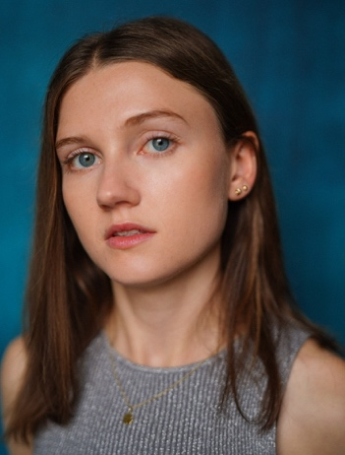
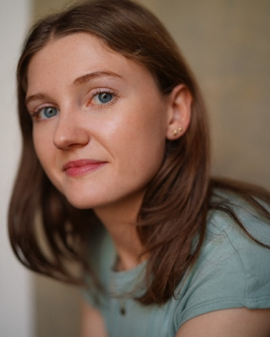
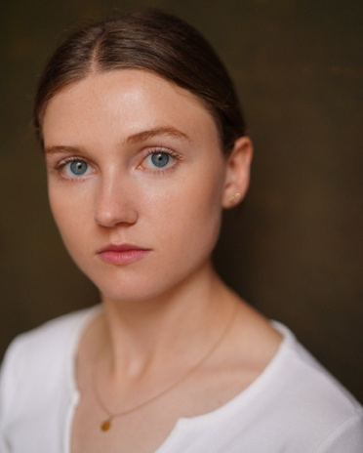

Hello,
I hope this letter finds you well.
My name is Rose. I am a 21-year-old soon to be Acting for Contemporary Theatre BA Hons Graduate student from Chichester University. I am a passionate young performer, theatre-maker, artivist and clown based in North Wales, UK. My work raises awareness through a comedic approach that connects with audiences. I use physical theatre and an improvisation driven devising process to create my performance content, working with different materials, and enjoy collaborating creatively with fellow artists and peers.
My mission is to move into the industry as an independent practitioner. A theatre maker and performer who uses the creativity of imagination to teach and inform through my work, while making people giggle along the way. To explore the possibilities of theatre to create playful, provocative art that engages audiences and invites questioning and reflection about contemporary issues and struggles. My work hopes to connect with audiences and uses physical comedy and an experimental approach to performance practise. I want to grow my skills and expand on my experience in the industry. I believe in the power theatre and film holds to create change, in hopeful actions and the importance to continue making work and support the arts community.
Some of my work stems from an autobiographical starting point, others are social or political commentary. Comedy, immersion, participation and experimentation are important to my artistic process. I’m a big fan of the power of laughing together. From project to project, my work takes a variety of different aesthetic forms and presentation. I devise solo performances, collaborative ensemble pieces with fellow artists and installation art.

A quote that sums me up - ‘If the work is playful it becomes pleasurable, and when you’re enjoying yourself you get bolder and take more risks.’ (Wright, 2007: 27).

I have attached a link to my spotlight page which displays further headshots, a short on sight showreel and a broader description of me as a performer and the skills I currently hold. I have recently gained representation with Pangolily Talent Management and plan to grow my career and portfolio in Film, TV and Theatre, and expand my connections throughout the industry.
Thank you for taking the time to read this letter and consider my application.
Best wishes,
Rose Pontin.
https://www.spotlight.com/6298-9057-9539
TN +44 7837219332
Instagram – rose_acting_
Email – rdpontin@icloud.com

