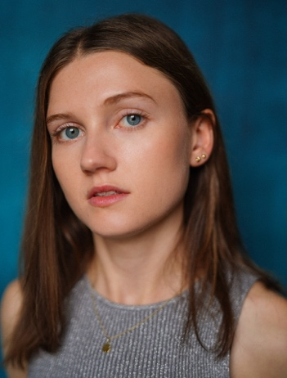
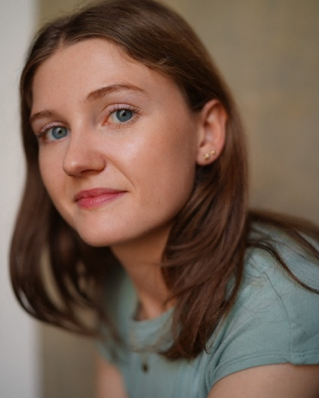
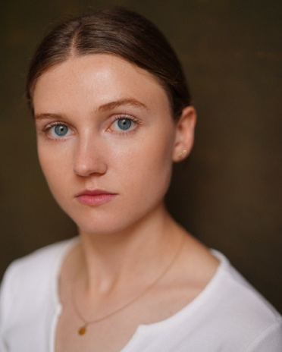

Hello,
I hope this letter finds you well.
My name is Rose Dorothy Pontin. I am a recent graduate Acting for Contemporary Theatre BA Hons student from Chichester University. I am passionate about physical theatre, enhancing my practise and devising within an ensemble. My work at university explored clowning, physical comedy, experimental and postdramatic theatre. I wish to continue pursuing and building on my skills and training after graduation and build a career in the performance industry.
This would be an amazing opportunity to learn and meet new people, grow my confidence and expand my toolkit. I am keen to push myself in the industry and grow my professional development. I am driven, passionate, hardworking and ready to throw myself into this experience and be challenged! I believe I would be a good fit for this role as …
I have attached a link to my spotlight page which displays further headshots, a short on sight showreel and a broader description of me as a performer and the skills I currently hold.
Thank you for taking the time to read this letter and consider my application.
Best wishes,
Rose Pontin.
https://www.spotlight.com/6298-9057-9539
TN +44 7837219332
Instagram – rose_acting_
Email – rpontin.acting@gmail.com

